IOWAWORKS – IOWA VALLEY – REGION 6
CHIEF ELECTED OFFICIALS AND REGIONAL WORKFORCE DEVELOPMENT BOARD MEETING
Wednesday, July 17, 2019 at 5:00 P.M.
TEMPORARY LOCATION
204 ½ W. State Street, Marshalltown, Iowa 50158
TENTATIVE AGENDA

- Call to Order-Marty Hardon
  - Additions/Deletions to the Agenda
  - Approval of the Agenda

CEO Action:
Motion by_________, second by________, to ________ the agenda as printed.

Roll Call Vote: Ayes______ Nays______
RWDB Action:
Motion by_________, second by________, to ________ the agenda as printed.

Roll Call Vote: Ayes______ Nays______

2.0 Correspondence and/or Visitors-Marty Hardon

3.0 Economic Development Updates-Marty Hardon
3.1 Tama County Update -

3.2 Poweshiek County Update -

3.3 Marshall County Update -

3.4 Hardin County Update-

- Partner Updates-Marty Hardon
5.0 Action Items-Marty Hardon
5.1 Approval of Minutes (April 17, 2019 and May 29, 2019 electronic vote)
CEO Action:
Motion by________, second by__________, to __________the April 17, 2019 and May 29, 2019 minutes as written.

Roll Call Vote: Ayes______ Nays______
RWDB Action:
Motion by________, second by__________, to _________the April 17, 2019 and May 29, 2019 minutes as written.

Roll Call Vote: Ayes______ Nays______

5.2 Approval of Additional Member to Youth Standing Committee-Rachel Porath

CEO Action:
Motion by________, second by__________, to _________additional member Eric Goslinga to Youth Standing Committee.

Roll Call Vote: Ayes______ Nays______
RWDB Action:
Motion by________, second by__________, to _________additional member Eric Goslinga to Youth Standing Committee.

Roll Call Vote: Ayes______ Nays______

6.0 Discussion/ Information Items: Rachel Porath
- Rapid Response Distribution (Attachments: Narrative, DW 30K)
- Becky Hassett started July 1 in a combined position as Director of Support Services. This position still covers WIOA.
- Lauren (Beth) Severidt Retirement
- New Position
- Fiscal Modification (Attached: 17-W-06 Mod A10)
- Limelight Leadership Academy
- Region 6 File Monitoring (Report Letter Attached) Report Document will not be attached as it contains participants personal information.
7.0 Upcoming Events/Programs Updates

8.0 Schedule for Future Meetings
Future RWDB/CEO meetings will be held quarterly – January, April, July and October. The meetings will be held at 5:00 p.m. on the 3rd Wednesday of these months. Next meeting will be October 16, 2019.

9.0 Adjournment
The meeting is adjourned at _______p.m.

Submitted by Lisa R. Gassman
Board Secretary

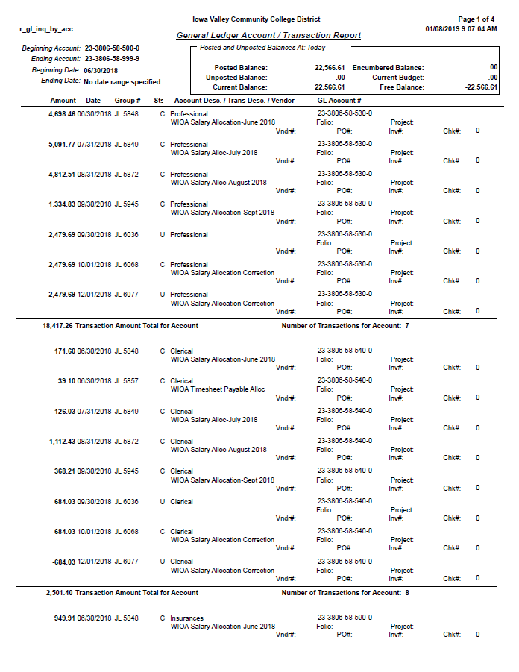

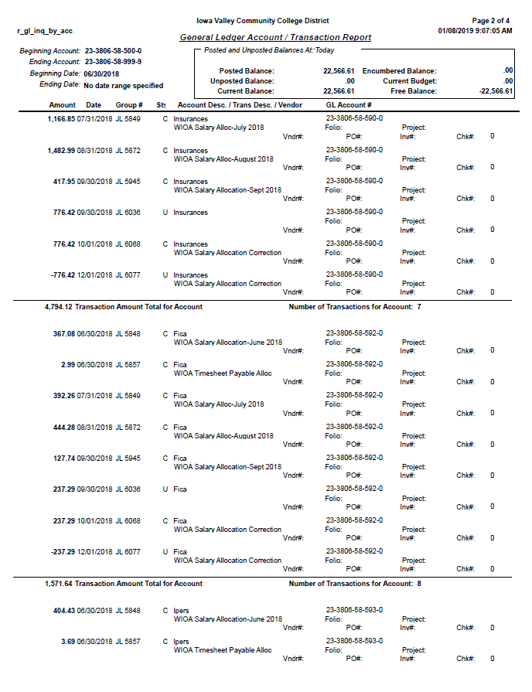

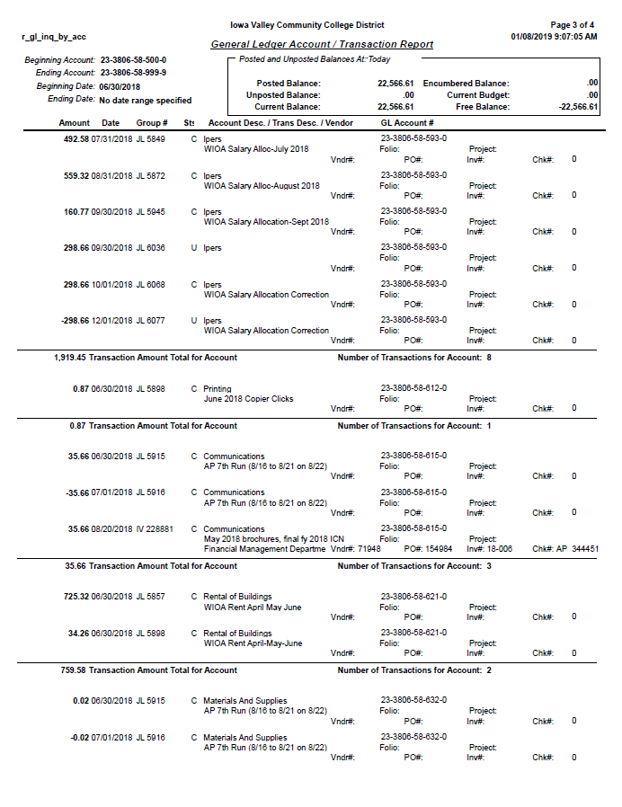

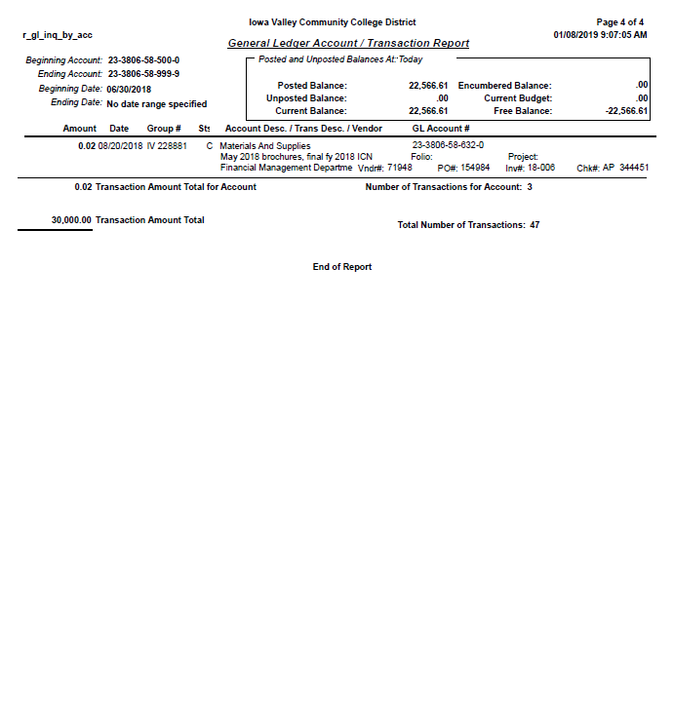

Rapid Response Funds Distribution
Rapid Response funds were available from June 1, 2018 to June 30, 2019. During that time we had several events involving the Dislocated Worker populations. Unfortunately, we had two businesses close during that time and a massive tornado taking out one of the town’s largest employers. At that time, it was uncertain whether or not they would rebuild, so we treated the event as a rapid response serving several hundred dislocated workers. Besides the Rapid Response meetings, efforts went (and continue to go) toward several other employment events such as workshops and Career Fairs. The Career Development Advisor working with the Dislocated Worker population also serves on various committees to help with employer engagement and staying abreast of what is happening in the service area. A detailed list of activities is shown below.
Rapid Response Meetings
July 25: meeting with Lennox employees were held in the DeJardin Hall at Iowa Valley Continuing Education. Between 450-500 Lennox employees attended the morning or afternoon session. Lennox was one of the businesses that was heavily damaged from the tornado disaster on July 19. Staff from both the Marshalltown and Des Moines IowaWORKS offices assisted with the meetings for Lennox employees. Local organizations also attended to talk about their services including Iowa Department of Vocational Rehabilitation (IVRS), Department of Human Services (DHS), Iowa Valley Continuing Education (IVCE), IowaWORKS, Mid-Iowa Community Action (MICA), and Primary Health Care. Several group meetings times were offered to the workers for them to come to the Marshalltown office and get assistance with filing their Unemployment Claims. This took place over two days. Individual meetings were set on an “as-requested” basis for the dislocated workers.

July 6: Younkers
Contacted the manager of the store and set up a meeting on May 2 to find out time for a Rapid Response meeting, how many employees would be affected and other relevant information to prepare for the employee meetings. Employee meetings were held at the Younkers store at 9am and again at 5pm to talk with remaining employees regarding their Unemployment and available services; a total of 12 employees attended. Some of the workers wanted to have individual meetings and those were scheduled for a later date

August 23: Kmart
Two meetings were held for the closure of the local Kmart store (at the store) to ensure employees had the necessary information on Unemployment and available services; one meeting at 8am the other at 3pm. A total of 18 employees attended. After dislocation, several employees came in together and we worked with the groups to help them file for unemployment benefits. Some individual appointments were made to further assist the dislocated workers

Career Fair
September 20:
Region 6 Marshalltown IowaWORKS Iowa Valley partnered with Region 11 Des Moines IowaWORKS and the Ames Chamber of Commerce to hold the “Marshalltown Strong” Career Fair on September 20, 2018. It was held at Iowa Valley Continuing Education. There were 27 total employers and a little over 60
job seekers. Due to the room capacity, this fair had limited spacing so there was no room to have more employers participate. This fair DID NOT replace the annual career fair that will be held at Iowa Valley in the Spring. The goal was to assist dislocated workers to find new employment if they were not planning to, or were unable to return to their previous employment after the tornado that devastated the business district and did substantial damage to major employers in Marshalltown.
The Ames Chamber of Commerce helped sponsor this event and KDAO Radio Station actually broadcasted live the day of the event. They had employers, IowaWORKS staff, and Brenda Dryer from the Ames Chamber speak during the broadcast . The City Transit/Bus system of Marshalltown agreed to give rides at NO COST for any job seeker needing transportation to the fair. Job seekers were able to talk one-on-one with employers and many even had a casual interview with them.

Monthly Workshops:
Developing a Career Plan – Why it’s important to have a plan when looking for their future career
Researching Industry Trends – How to do labor market research on their chosen career field to see wages education needed, skills needed, and trends in employment
Excel Basics – Introduction to Excel for those who have never used the program or have very limited skills with Excel and how this might be useful for them with daily life
Word Basics - Introduction to Word for those who have never used the program or have very limited skills with Word and how they can use it in their everyday life.
Registered Apprenticeship Informational Session – provides information on what is a Registered Apprenticeship and how do the work. Discussion of RA throughout the state.
Core Partner Referral Meeting – A workshop that was developed with Core Partners so that interested participants needing services had the opportunity to hear what was available from those partners and have an immediate one-on-one into meeting with the partner representative. This has resulted in more effective referrals for the center and the partners
Fill in- As a facilitator for other workshops as needed.

Committees:
Business Partner Outreach – Working with core partners to project a unified front to employers showing how we all can help with their employment needs.
Organized the-Partner Business Outreach Group tour of the new Alliant Energy facility. The tour was given by Jim Fleming, MGS Maintenance Manager and Delania Halter, MGS Site Office Administrator. MGS is Marshalltown Generating Station.
Data Committee at Iowa Valley – Determining what data we need to review from different programs, gathering that information and looking at the overall data to see how our program is doing, and if we are meeting our goals?
Lunch-N-Learn – monthly meetings with community resources to learn more about their programs and how we can access the.
Staff In-Service Day – worked on the committee that developed the training for our staff in-service day in October. Planning started several months ahead.

Kim Reynolds, Governor
Adam Gregg, Lt. Governor
Beth Townsend, Director
June 21, 2019
To: Jason Roudabush, Chief Elected Official Chair
Marty Hardon, Local Board Chair
Rebecca Hassett, Title I Director
RE: TITLE I MONITORING
Monitoring of Title I program files for program year 2018 was completed on April 26, 2019 by the Iowa Workforce Development (IWD) Workforce Services Division.
Monitoring included a comprehensive, electronic audit of three (3) Adult, three (3) Dislocated Worker, and two (2) Youth program files from point of program application to exit, if applicable. Attention was given to case notes, data entry, participant eligibility, verification, and compliance with Title I policies, as well as state and local plans.
Attached is the monitoring report for Region 6 where you will find:
- Strengths – Areas of notable effectiveness that may be recognized as best practices.
- Areas of Concern – Issues of quality that are not attributable to a failure to comply with policy or program requirements that may be a symptom of a larger problem or lead to non-compliance in the future. Concerns may include recommendations from IWD and do not require a response from the region.
- Findings – Issues that are cited as non-compliance with policy or program requirements. Findings require a written response from the region, to include a corrective action plan, to resolve the finding.
Please use the designated Region Response section of the monitoring report to address the identified findings. Your written response with corrective action plans is due no later than June 28, 2019
We appreciate your assistance in providing the documentation necessary to complete the monitoring. Thank you for your dedication and services provided to IWD and Title I participants.
Please contact me if you have any questions or concerns.
Sincerely,
Michelle McNertney
Bureau Chief - WIOA, Title I and Title III
Iowa Workforce Development
1000 East Grand Avenue
Des Moines, IA 50319
Phone: 515-242-0408
michelle.mcnertney@iwd.iowa.gov

