IOWAWORKS – IOWA VALLEY – REGION 6
CHIEF ELECTED OFFICIALS AND REGIONAL WORKFORCE DEVELOPMENT BOARD MEETING
Wednesday, July 31, 2019 at 5:00 P.M.
TEMPORARY LOCATION
204 ½ W. State Street, Marshalltown, Iowa 50158
MINUTES
CEO Members- Attended: Jason Roudabush, Steve Salasek (Vice Chair) and Kendall Jordan. Lance Granzow was absent.

RWDB Members- Jason Roudabush, Marty Hardon (Chair), Nancy Roethler (Vice Chair), Bob Jeske, Jim Hunt, Kathleen Geiken, Jackie Gray, Arturo Sanchez and Rachel Bly

Members absent: Eric Evans, Lori Wildman, Jason Schomer, Brian Sokol, Jon Nunez and Lynn Olberding

Others Present- Rebecca Hassett

- Call to Order-Marty Hardon
  - Additions/Deletions to the Agenda-none
  - Approval of the Agenda

CEO Action:
Motion by Jordan, second by Roudabush, to approve the agenda as printed.

Roll Call Vote: Ayes___X___ Nays______
RWDB Action:
Motion by Jeske, second by Bly, to approve the agenda as printed.

Roll Call Vote: Ayes___X___ Nays______

2.0 Correspondence and/or Visitors-none

3.0 Economic Development Updates-Marty Hardon
3.1 Tama County Update –Kendall Jordan
- A new Economic Development Director-Katherine O.
- A part time new truck wash in Tama
- Theater addition in Toledo

3.2 Poweshiek County Update –Jason Roudabush
- Phase 1 of wind turbines completed. MidAmerican has started phase 2
- Manatt’s and Brownells looking for employees
- Brooklyn Iowa-Opera House turning into movie theatre

3.3 Marshall County Update –Steve Salasek and Lisa Gassman
- North Center St. Bridge Detour
- Courthouse renovation update
- Planning and Zoning Director, John Kunc, passed away July 14, 2019-Interim Administrator Jessica Sheridan from Hardin County

3.4 Hardin County Update-No report.

- Partner Updates-Marty Hardon
Arturo Sanchez-report attached.
5.0 Action Items-Marty Hardon
5.1 Approval of Minutes (April 17, 2019 and May 29, 2019 electronic vote)
CEO Action:
Motion by Roudabush, second by Salasek, to approve the April 17, 2019 and May 29, 2019 minutes as written.

Roll Call Vote: Ayes___X___ Nays______
RWDB Action:
Motion by Gray, second by Roethler, to approve the April 17, 2019 and May 29, 2019 minutes as written.

Roll Call Vote: Ayes___X___ Nays______

5.2 Approval of Additional Member to Youth Standing Committee-Rebecca Hassett

CEO Action:
Motion by Roudabush, second by Jordan, to approve additional member Eric Goslinga to Youth Standing Committee.

Roll Call Vote: Ayes___X___ Nays______
RWDB Action:
Motion by Hunt, second by Sanchez, to approve additional member Eric Goslinga to Youth Standing Committee.

Roll Call Vote: Ayes___X___ Nays______
5.3 Memorandum of Understanding Extension for ALL Regions-Rebecca Hassett

CEO Action:
Motion by Salasek, second by Roudabush, to approve the current MOU’s with partners under #3 of the attachment to June 30, 2020.

Roll Call Vote: Ayes___X___ Nays______

RWDB Action:
Motion by Hunt, second by Roethler, to approve the current MOU’s with partners under #3 of the attachment to June 30, 2020.

Roll Call Vote: Ayes__X____ Nays______

6.0 Discussion/ Information Items: Rebecca Hassett
- Rapid Response Distribution (Attachments: Narrative, DW 30K)
- Becky Hassett started July 1 in a combined position as Director of Support Services. This position still covers WIOA –Half of Becky’s time at Iowa Valley
- Lauren (Beth) Severidt Retirement-Rachel Porath is doing dislocated and adult worker
- New Position-Writing up a job description is in the works
- Fiscal Modification (Attached: 17-W-06 Mod A10)
- Limelight Leadership Academy
- Last Dollar Scholar Funding WIOA funds can be used as a last resort as it contains participants’ personal information
- Title 1 Monitoring
- Realignment-Timeline is June 30, 2020
- IowaWorks system having some issues- will provide accurate reports when available
7.0 Upcoming Events/Programs Updates

8.0 Schedule for Future Meetings
Future RWDB/CEO meetings will be held quarterly – January, April, July and October. The meetings will be held at 5:00 p.m. on the 3rd Wednesday of these months. Next meeting will be October 16, 2019.

9.0 Adjournment
The meeting is adjourned at 5:48p.m.

Submitted by Lisa R. Gassman
Board Secretary

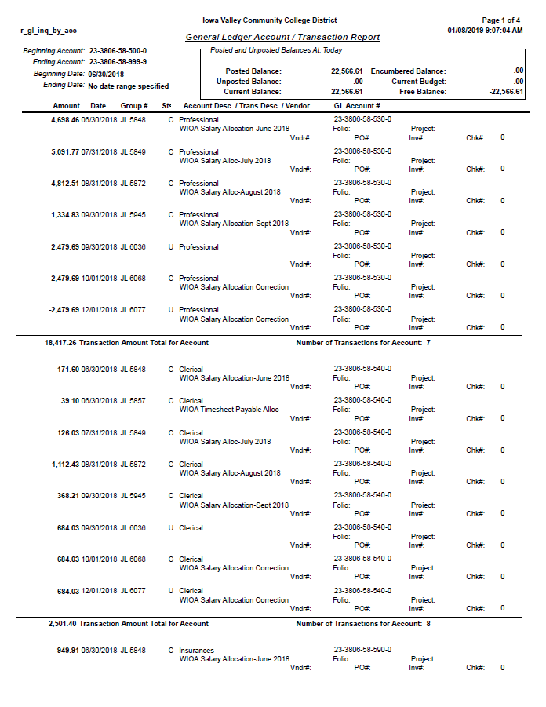

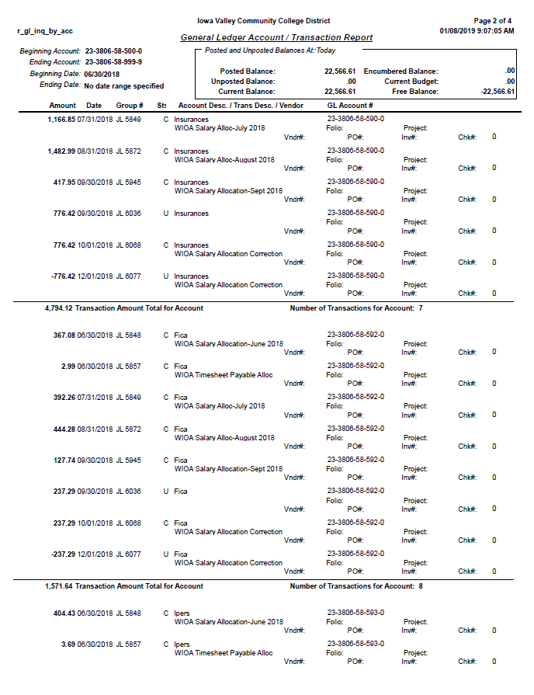

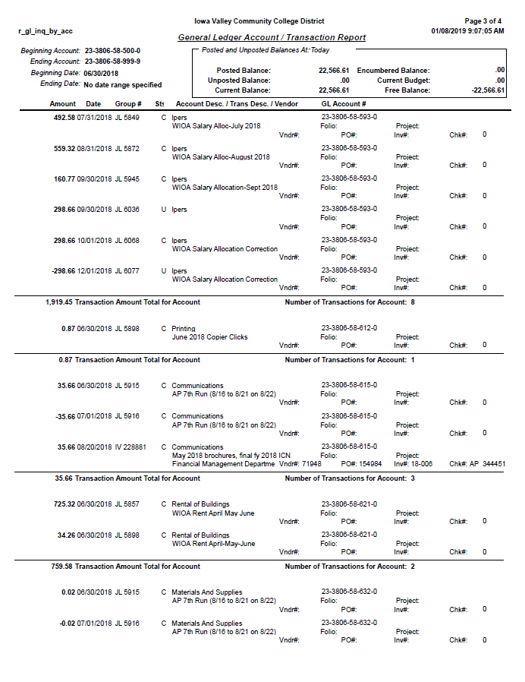

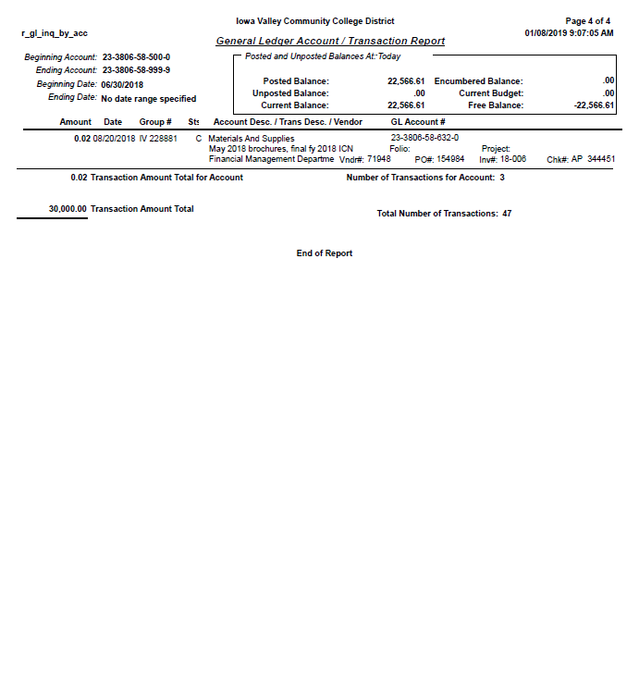

Rapid Response Funds Distribution
Rapid Response funds were available from June 1, 2018 to June 30, 2019. During that time we had several events involving the Dislocated Worker populations. Unfortunately, we had two businesses close during that time and a massive tornado taking out one of the town’s largest employers. At that time, it was uncertain whether or not they would rebuild, so we treated the event as a rapid response serving several hundred dislocated workers. Besides the Rapid Response meetings, efforts went (and continue to go) toward several other employment events such as workshops and Career Fairs. The Career Development Advisor working with the Dislocated Worker population also serves on various committees to help with employer engagement and staying abreast of what is happening in the service area. A detailed list of activities is shown below.
Rapid Response Meetings
July 25: meeting with Lennox employees were held in the DeJardin Hall at Iowa Valley Continuing Education. Between 450-500 Lennox employees attended the morning or afternoon session. Lennox was one of the businesses that was heavily damaged from the tornado disaster on July 19. Staff from both the Marshalltown and Des Moines IowaWORKS offices assisted with the meetings for Lennox employees. Local organizations also attended to talk about their services including Iowa Department of Vocational Rehabilitation (IVRS), Department of Human Services (DHS), Iowa Valley Continuing Education (IVCE), IowaWORKS, Mid-Iowa Community Action (MICA), and Primary Health Care. Several group meetings times were offered to the workers for them to come to the Marshalltown office and get assistance with filing their Unemployment Claims. This took place over two days. Individual meetings were set on an “as-requested” basis for the dislocated workers.

July 6: Younkers
Contacted the manager of the store and set up a meeting on May 2 to find out time for a Rapid Response meeting, how many employees would be affected and other relevant information to prepare for the employee meetings. Employee meetings were held at the Younkers store at 9am and again at 5pm to talk with remaining employees regarding their Unemployment and available services; a total of 12 employees attended. Some of the workers wanted to have individual meetings and those were scheduled for a later date

August 23: Kmart
Two meetings were held for the closure of the local Kmart store (at the store) to ensure employees had the necessary information on Unemployment and available services; one meeting at 8am the other at 3pm. A total of 18 employees attended. After dislocation, several employees came in together and we worked with the groups to help them file for unemployment benefits. Some individual appointments were made to further assist the dislocated workers

Career Fair
September 20:
Region 6 Marshalltown IowaWORKS Iowa Valley partnered with Region 11 Des Moines IowaWORKS and the Ames Chamber of Commerce to hold the “Marshalltown Strong” Career Fair on September 20, 2018. It was held at Iowa Valley Continuing Education. There were 27 total employers and a little over 60
job seekers. Due to the room capacity, this fair had limited spacing so there was no room to have more employers participate. This fair DID NOT replace the annual career fair that will be held at Iowa Valley in the Spring. The goal was to assist dislocated workers to find new employment if they were not planning to, or were unable to return to their previous employment after the tornado that devastated the business district and did substantial damage to major employers in Marshalltown.
The Ames Chamber of Commerce helped sponsor this event and KDAO Radio Station actually broadcasted live the day of the event. They had employers, IowaWORKS staff, and Brenda Dryer from the Ames Chamber speak during the broadcast . The City Transit/Bus system of Marshalltown agreed to give rides at NO COST for any job seeker needing transportation to the fair. Job seekers were able to talk one-on-one with employers and many even had a casual interview with them.

Monthly Workshops:
Developing a Career Plan – Why it’s important to have a plan when looking for their future career
Researching Industry Trends – How to do labor market research on their chosen career field to see wages education needed, skills needed, and trends in employment
Excel Basics – Introduction to Excel for those who have never used the program or have very limited skills with Excel and how this might be useful for them with daily life
Word Basics - Introduction to Word for those who have never used the program or have very limited skills with Word and how they can use it in their everyday life.
Registered Apprenticeship Informational Session – provides information on what is a Registered Apprenticeship and how do the work. Discussion of RA throughout the state.
Core Partner Referral Meeting – A workshop that was developed with Core Partners so that interested participants needing services had the opportunity to hear what was available from those partners and have an immediate one-on-one into meeting with the partner representative. This has resulted in more effective referrals for the center and the partners
Fill in- As a facilitator for other workshops as needed.

Committees:
Business Partner Outreach – Working with core partners to project a unified front to employers showing how we all can help with their employment needs.
Organized the-Partner Business Outreach Group tour of the new Alliant Energy facility. The tour was given by Jim Fleming, MGS Maintenance Manager and Delania Halter, MGS Site Office Administrator. MGS is Marshalltown Generating Station.
Data Committee at Iowa Valley – Determining what data we need to review from different programs, gathering that information and looking at the overall data to see how our program is doing, and if we are meeting our goals?
Lunch-N-Learn – monthly meetings with community resources to learn more about their programs and how we can access the.
Staff In-Service Day – worked on the committee that developed the training for our staff in-service day in October. Planning started several months ahead.

Kim Reynolds, Governor
Adam Gregg, Lt. Governor
Beth Townsend, Director
June 21, 2019
To: Jason Roudabush, Chief Elected Official Chair
Marty Hardon, Local Board Chair
Rebecca Hassett, Title I Director
RE: TITLE I MONITORING
Monitoring of Title I program files for program year 2018 was completed on April 26, 2019 by the Iowa Workforce Development (IWD) Workforce Services Division.
Monitoring included a comprehensive, electronic audit of three (3) Adult, three (3) Dislocated Worker, and two (2) Youth program files from point of program application to exit, if applicable. Attention was given to case notes, data entry, participant eligibility, verification, and compliance with Title I policies, as well as state and local plans.
Attached is the monitoring report for Region 6 where you will find:
- Strengths – Areas of notable effectiveness that may be recognized as best practices.
- Areas of Concern – Issues of quality that are not attributable to a failure to comply with policy or program requirements that may be a symptom of a larger problem or lead to non-compliance in the future. Concerns may include recommendations from IWD and do not require a response from the region.
- Findings – Issues that are cited as non-compliance with policy or program requirements. Findings require a written response from the region, to include a corrective action plan, to resolve the finding.
Please use the designated Region Response section of the monitoring report to address the identified findings. Your written response with corrective action plans is due no later than June 28, 2019
We appreciate your assistance in providing the documentation necessary to complete the monitoring. Thank you for your dedication and services provided to IWD and Title I participants.
Please contact me if you have any questions or concerns.
Sincerely,
Michelle McNertney
Bureau Chief - WIOA, Title I and Title III
Iowa Workforce Development
1000 East Grand Avenue
Des Moines, IA 50319
Phone: 515-242-0408
michelle.mcnertney@iwd.iowa.gov

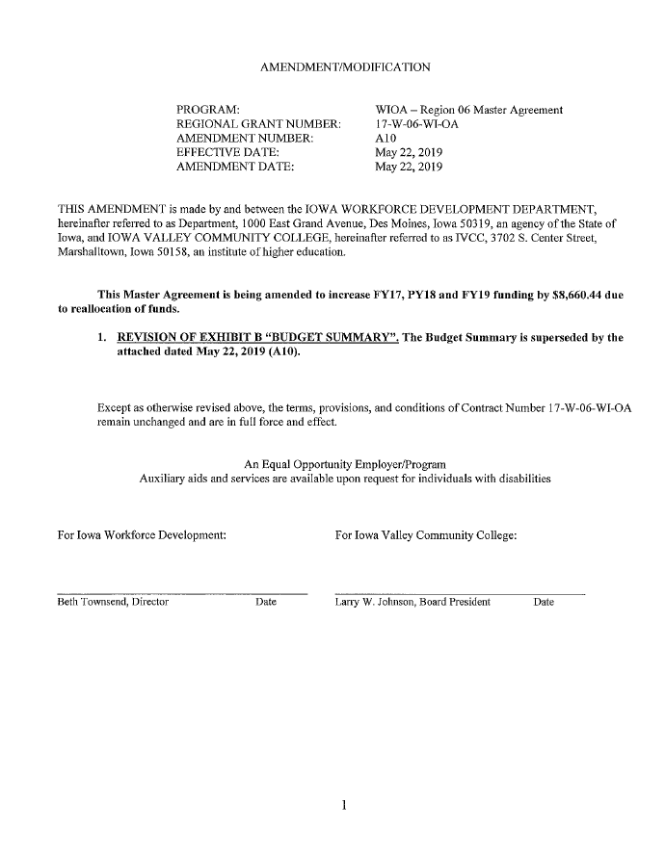

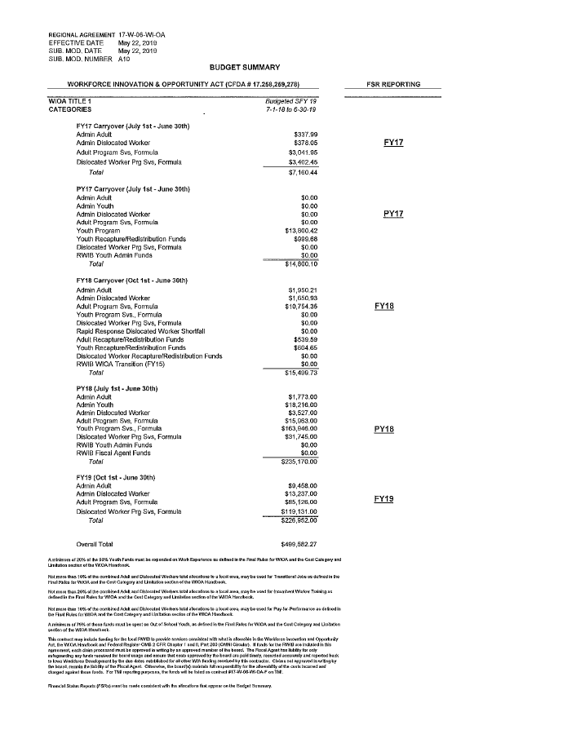

July 11, 2019
WORKFORCE DEVELOPMENT FIELD INFORMATION MEMO NO: 19-02
TOPIC: Memorandum of Understanding (MOU) Guidance for Local Workforce Development Boards
1. Purpose: To transmit guidance on the extension or renegotiation of MOUs in the Local Service Delivery Areas.

2. Background: WIOA section 121(a)(1) and section 121(c) require that Local Workforce Development Boards (LWDBs), with the agreement of the Chief Elected Officials (CEOs), enter into an MOU with the one-stop partners concerning the operation of the one-stop delivery system in the local area. The existing MOUs in each local area in Iowa were negotiated and in place from July 1, 2016 – June 30, 2019.

3. Substance: The LWDBs must complete one of the below options in regards to MOUs in their local areas:

a. Extend Existing MOUs with No Changes

To complete this option, the LWDB must provide notice to all one-stop partners that the terms of the existing MOU are now in effect from the start date of the original MOU (most likely July 1, 2016) through an end date of the LWDB’s choosing, not to extend beyond June 30, 2020.
b. Renegotiate MOUs

If a local area chooses to renegotiate its existing MOU, all required and additional partners as identified in WIOA sections 121(b)(1) and 121(b)(2) must be included. In addition, the MOU must contain all required contents identified in WIOA section 121(c), including the Infrastructure Funding Agreement. Any renegotiation of MOUs at this time will be completed in the absence of state policy and may result in a non-compliant agreement that will be required to be renegotiated at such time that state policy is published. State policy is currently being developed in conjunction with required and additional partners.
4. Action: This information should be shared with LWDB and CEO Board Members as well as appropriate One-Stop and other partner staff.

Each LWDB must provide notice of the extension or renegotiate the MOU and provide a copy of that documentation to Iowa Workforce Development no later than August 31, 2019. Please submit required documentation to WIOAgovernance@iwd.iowa.gov.
5. Effective Date: This field memo is effective from the date of this memo.

6. Contact: For questions related to the information in this issuance, contact Michelle McNertney at 515-242-0408 or michelle.mcnertney@iwd.iowa.gov.

Cathy Ross, Chief Operating Officer
Workforce Services
Iowa Workforce Development

July 24, 2019
WORKFORCE DEVELOPMENT FIELD INFORMATION MEMO: 19-03
TOPIC: Coordination of WIOA Title I funds and Iowa Last Dollar Scholarship
1. Purpose: To transmit guidance on the coordination of funding for WIOA Title I participants who are Iowa Last Dollar Scholarship recipients.

2. Background: 20 CFR § 680.230(b) states that one-stop centers must coordinate training funds available and make funding arrangements with one-stop partners and other entities. One-stop partners must consider the availability of other sources of grants to pay for training costs. Iowa Administrative Code 283-15.4(261) stipulates that federal and state non-repayable aid must be applied first before applying Last Dollar Scholarship funds.

3. Substance: WIOA implementing regulations require the coordination of available training funds so that WIOA funds supplement other sources of training grants. In many cases, this coordination will result in WIOA as the payer of last resort. However, it is also possible that this coordination will identify training grants that are not available until after WIOA funds have been applied. Because the Iowa Administrative Code requires the Last Dollar Scholarship to be awarded only after federal and state non-repayment aid is applied, Last Dollar Scholarship funds are not available until WIOA funds have been applied. Accordingly, WIOA funds must be applied first, and then any remaining need can be met using the Last Dollar Scholarship.

4. Action: This information should be shared with LWDB and CEO Board Members as well as appropriate American Job Center and other partner staff.

5. Effective Date: This field memo is effective from the date of this memo.

6. Contact: For questions related to the information in this issuance, contact Michelle McNertney at 515-242-0408 or michelle.mcnertney@iwd.iowa.gov.

Cathy Ross, Chief Operations Officer Workforce Services
Iowa Workforce Development

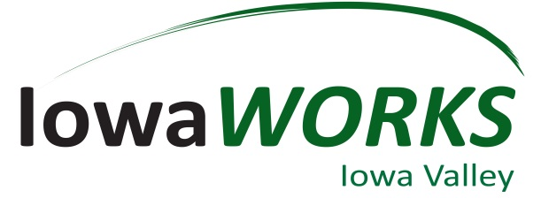
RWB Report –July 31st, 2019
IowaWORKS new case management system:
New IowaWORKS case management system is now live. It launched in June 2019. With this new system, we should now be WIOA compliant and should be able to report the correct data.

Because of the new system, other data provided in past report is not available for this report. We should be able to report new date in the next board meeting.

Fiscal Year Updates:
687 new members from May 1st 2019- July 31st, 2019- New Members that have visited or have utilized our services in the last 3 months.
- May 299
- June 196
- July 192

35 NCRC certificates awarded to job seekers.

Office Top Priorities:
- Office location continues to be the main priority for us. We are currently in a temporary lease until April 30, 2020.
- IowaWORKS new case management system.
- Registered Apprenticeships
- Future Ready Iowa- Marshalltown will be hosting a Fall Summit. When we get the date, we will send out to board and all employers in the Region.
- Home Base Iowa- When the new Business Marketing Specialist is on board, we will immediately start working with all counties and Economic Development groups to start developing Home Base Iowa communities.

Business Services Updates:
- 9 different employers hosted in the center for open interviews.
- 31 open interviews scheduled in the office.
- State of Iowa Initiatives.
  - Future Ready Iowa (70% of Iowa’s workforce to have education or training beyond high school by 2025). See attached Map and Dates for Future Ready Iowa Summits across the State.
  - Minority Unemployment subcommittee
  - Register Apprenticeships
  - Home Base Iowa
- Rapid Response Events/ Business Closings.
  - 07/30/2019 Iowa Works staff and service partners did 1 Rapid Response meetings for the Alliant Energy for their meter readers. About 4 staff were affected.
  - 06/17/2019 United Healthcare layoffs
- Past Events:
  - April 2 - Iowa Works partnered with Meskwaki Higher Education to hold the 3rd Annual College & Career Fair which was held at the Meskwaki Veteran's Convention Center in Tama.
  - April 9 - Iowa Works staff volunteered at Iowa Valley Continuing Education for the MCC Financial Literacy Fair with area high school students.
  - April 11 - Iowa Works staff volunteered to facilitate a poverty simulation in Brooklyn for the Poweshiek Development Leadership class.
  - April 17 - The Partner Lunch-N-Learn was held at the Iowa Valley Education & Training Center. Kathy Siebring and Patty Mendoza explained their services and the variety of classes they have.
  - April 19 - Iowa Works staff went to the Eldora State Training School to work with boys who were soon being released and needed to find employment.
  - April 25 - Neysa facilitated classes for 8th Grade Social Studies at Miller Middle School for Junior Achievement. The unit was about career exploratory so she explained Future Ready Iowa and had the students do an assessment and talk about what career path they plan on taking.
  - April 30 - NCRC testing for all seniors at East Marshall High School.
  - May 7 - Neysa gave Future Ready Iowa presentations to ESL classes at Iowa Valley's Education & Training center.
  - May 14 - Business Services spoke to the Iowa Valley Education & Training ESL classes about workshops and services offered at Iowa Works.
  - May 15 - Partner Lunch-N-Learn was held at Iowa Valley Continuing Education. Beth Severidt and Janet Stegmann spoke about the WIOA Adult and Youth programs.
  - June 3 - The new IowaWorks system went live. Compared to the old IWorks system, this system is modernized, user-friendly, and has the capability to do so much more.
  - June 19 - ECI (Employers Council of Iowa) event was held at the Iowa Works office with over 20 attendees. The topic was Immigration and the Work place with Special ICE Agent Brett Stanley giving the presentation to employers.
  - June 24 - Neysa gave Future Ready Iowa presentation to the Poweshiek Development Teacher Externship in Grinnell.
  - June 24-28 - Limelight Leadership Academy Youth event was held at Iowa Valley Continuing Education. Business Services helped with a registered apprenticeship mini fair and "The Shark Tank" during that week.
  - July 17 - Region 6 and Region 7 partnered to hold the first ever combined ECI event in Grundy Center because of sharing common borders. The topic was "Millennials and the Workplace."

- Upcoming Events:
  - August 8 & 9 - Iowa Works will have a booth at the Meskwaki Pow Wow in Tama for the first time.
  - August 13 - 16 - Business Services is assisting with the Teacher Externship for Marshalltown Community School District.
  - September 4 - ECI Event on Unemployment and SIDES at the Iowa Works office.
  - September 13 - Region 6 is having an Employer Summit on Registered Apprenticeships which will be held at the Alliant Energy Training Center in Marshalltown.

