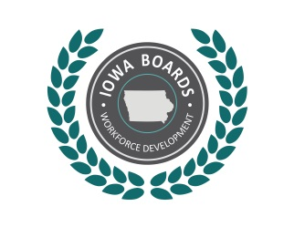 | Region _3-4_ Disability Access Committee  Draft Meeting Minutes
  - Date: August 12, 2019
Time: 9:00 am
Location: IowaWORKS office, Spencer

Meeting Minutes:
- Call to order at 9:05 am
- Introductions/Role call- Present: Lori Kolbeck, Sarah Breems-Diekevers, Kim Wilson, Gloria Graves, Kara Merchant (guest)
- Approval of agenda- Kim Wilson motion to approve. Sarah Breems-Diekevers seconded. All in favor, none opposed.
- Approval of previous meeting minutes- Kim Wilson motion to approve. Sarah Breems-Diekevers second. All in favor, none opposed.
- Open Issues
  - Program Accessibility- Lori Kolbeck has shared the Section 188 Reference Guide. Will utilize strategies as the core leadership team works on integration continuum to incorporate disability into plans. ( https://www.dol.gov/oasam/programs/crc/188Guide.htm )
  - Training for staff- Lori has shared videos available on Future Ready Iowa site, and videos on accommodations and AT by Solution Showcase by JAN. . Will utilize in trainings with staff. Lori Kolbeck will share at Regional Partner meeting.
  - Discussed ideas for NDEAM- Kara Merchant is leading plans through a sub committee.. Working with Kim Wilson and the Spencer AD council. Arranging an employer speaker panel to talk about successes in hiring and accommodations. Will bring IowaWORKS into planning. Consider CRP involvement.
- New business- none
- Public comment- none
- Schedule next meeting- Next meeting scheduled in November
- Adjournment at 9:45am. Motion by Sarah Breems-Diekevers, Second by Kim Wilson.

