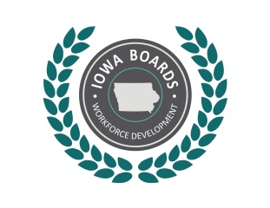 | Notice of Public Meeting:  Disability Access Committee of the  Region 3-4Workforce Development Board
Date: | February 11,2019
Time: | 10:00 am
Place: | Region 3-4 IowaWORKS office, 217 W 5th St, Spencer, IA 51301

Phone:
Internet: | Contact Lori Kolbeck if this option is needed, this will be available via Google Meets

Tentative Agenda:
- Call to order
- Introductions/Role call/Establish Roll Call
- Approval of agenda
- Approval of July 10, 2018 meeting minutes
- Open Issues
  - Follow up on physical accessibility
  - Follow up accommodation checklist/staff survey and identify next steps
- New business
- Public comment
- Schedule next meeting
- Adjournment

Accommodations:
Accommodations are available upon request for individuals with disabilities. If you need an accommodation, please contact:
Name: Lori Kolbeck
Email: Lori.Kolbeck@iowa.gov
Phone: (515) 573-8175

More Information:
For more information, please visit: www.IowaWDB.gov

