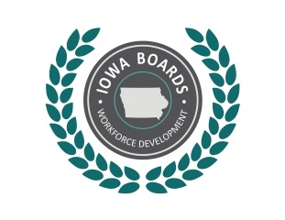 | Notice:  Region I Disability Access Committee Meeting
Date: | Tuesday, NOVEMBER 10, 2020
Time: | 1:30 P.M.
Place: | IOWA VOCATIONAL REHABILITATION SERVICES  2600 DODGE STREET, SUITE NW2, DUBUQUE, IA 52003  The meeting will be held via zoom at https://nicc.zoom.us/j/94964322408 or connect via phone by dialing 1 301 715 8592 and entering Meeting ID: 949 6432 2408
Phone: | 563-588-4697

Tentative Agenda:
- Call to Order.
- Approval of Agenda.
- Establish Quorum.
- Action Item: Approval of the minutes from the October 13, 2020, Region I Disability Access Committee meeting.
- WINTAC Next Steps.
- Follow up to question on current three DAC committees being combined into one.

Accommodations:
Accommodations are available upon request for individuals with disabilities. If you need an accommodation, please contact:
Nancy Steffensmeier
Email: nancy.steffensmeier@iowa.gov
Phone: 563-588-4697

More Information:
For more information, please visit: www.IowaWDB.gov

