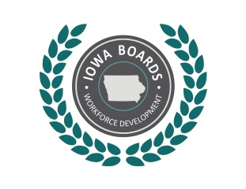 | Notice of Public Meeting:  Disability Awareness Committee of the  Region 13 Workforce Development Board
Date: | June 25, 2018
Time: | 3:00 p.m. – 4:00 p.m.
Place: | IowaWorks 300 West Broadway, Council Bluffs, IA 51503
Phone: | 712.328.3821
Internet: | Sally.Rolf @Iowa.gov

Tentative Agenda:
- Call to Order.
- Establish quorum.
- Approval of Agenda.
- Approval of previous meeting minutes.
- Discussion:
  - Committee membership
  - Core partner training
  - Ticket to Work
  - Benefits planner
  - Referral process review
- Committee Report.
- Accommodation Checklist.
- Action Item: Approve the accommodation checklist and submit to the State Disability Access Committee.
- Adjournment.

Accommodations:
Accommodations are available upon request for individuals with disabilities. If you need an accommodation, please contact:
Sally Rolf, IVRS Supervisor
Email: sally.rolf@iowa.gov
Phone: 712.328.3821
For more information, please visit: www.IowaWDB.gov

