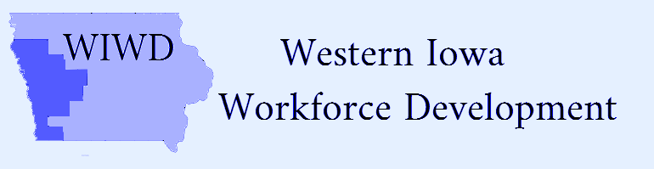
Voting Members | Present | Not Present
Craig Anderson | yes
Alan Armstrong | yes
Scott Belt | yes
Tom Brouilette |  | x
Ranell Drake |  | x
Raymond Drey | yes
Steve Green | yes
Darin Haake | yes
Randy Hickey |  | x
Jack Lloyd | yes
Lonnie Mayberry |  | x
Wane Miller | yes
John Muir |  | x
Keith Radig | yes
Rich Ruggles | yes
Erik Skoog | yes
Rick Thompson | yes
Walter Utman |  | x

Attendees
Shawn Fick
Tammy Herbert
Rick Hunsaker
Jean Logan
Kaylene Page
Linda Rouse
Mark Thomsen

Date: Monday, August 3, 2020/Time: 3:00pm
Location: Bank Iowa Building-1108 Broadway, Denison Iowa
CEO Board Meeting Minutes
Action Item
Call to Order/Pledge of Allegiance-Wane Miller
Action item
Introductions
Action item
Roll Call and establish Quorum
Action item
Approval of Agenda-motion made by Craig Anderson and 2nd by Keith Radig-Unanimously approved
Action item
Approve Agenda/Minutes of Previous Meeting-n/a
Action item-new business
- Adopt CEO By-Laws-term limit discussion. Motion made by Craig Anderson and 2nd by Keith Radig to accept as written. Unanimously approved. Motion carried.
- Review and discussion of transportation/travel mileage rates. Motion made by Stephen Green for $.50 per mile. 2nd by Jack Lloyd. Unanimously approved. Motion carried.
- Standing Committees-Wane discussed development of Finance Committee/Keith made a motion to continue with Executive Committee exclusively until development of Local Board. Wane 2nd motion. Unanimously approved. Motion carried.
Action item
Fiscal Agent Financial Report
- Rick Hunsaker Executive Director Region XII COG/Mark Thomsen-please refer to attached graph. Discussed options regarding potential Service Provider Budgets (percentages). Keith made Motion to approve 60% option. Stephen 2nd. Eleven voting members approved. One opposed. Motion carried.
Action item
Service Provider Reports:
- Kaylene Page; Director of Workforce Development IWCC-discussed the Disaster Recovery Employment Program (Flood Grant)
- Shawn Fick; Direct of Missions, Goodwill of the Great Plains-reported a strong demand continues for workers in several areas of the economy.
- Linda Rouse; District Manager, American Job Center Division, Iowa Workforce Development-question and answer session.
Action item
Nomination Form, WIWD Recruitment Form, Next Meeting
Action item
Public Comments-none
Action item
Motion to Adjourn made by Wane. 2nd Keith.
Next meeting tentatively scheduled for September 16, 2020 at 3p.m. in Denison, Iowa.

