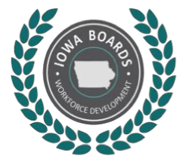
To: LWDB Members/CLEO Members
Re: Southwest Iowa Local Workforce Development Board Meeting
The Southwest Iowa Local Workforce Development Board meeting will be on Monday, October 17 at 6:30 pm on Zoom.
Join Zoom Meeting
https://us02web.zoom.us/j/83333874749
Meeting ID: 833 3387 4749
No password
If you will be unable to attend this meeting, please call or email Jesse Bolinger,641-202-6083 or jesse@bolinger.org prior to Monday.
The agenda is as follows:
- Call to Order: Katrina Fleharty-Chair
- Roll Call: Jesse or Amanda
- Minutes of the July meeting (Needs Approval)
- October Agenda (Add Items/Needs Approval)
- New Director & Board Member Introductions
- Iowa Workforce Development Guests:
Michelle McNertney, Wendy Greenman, ************
- 7) Business items of the LWDB
  - Executive Committee Updates
  - Operations Committee Updates-Darla Helm, Chair
  - One Stop Operator Update: Ashley West
  - Ad-Hoc Feasibility Committee Update: Wayne Pantini, Chair
  - Disability Access Committee Updates (ADA Assessment)-Sarah Baebler-Hall and Michael Hruska, co-chairs
  - Finance Committee Updates-Carol Smith, Chair
● Expenditure Report
- 8) Partner Report Updates (Title I, Title II, Title III, Title IV),
- 9) Reports from other representative entities (SWCC-Economic Dev., SIRHA) and Public Comment
- 10) Establish Next Meeting: January 23, 2023 at 6:30 pm
- 11) Adjournment

