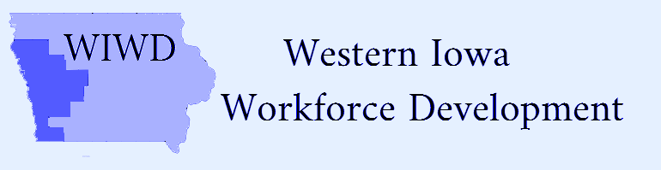
Voting Members | Present | Not Present
Craig Anderson | yes
Alan Armstrong |  | x
Scott Belt | yes
Tom Brouilette |  | x
Ranell Drake | yes
Raymond Drey | yes
Darin Haake | yes
Randy Hickey |  | x
Jack Lloyd | yes
Lonnie Mayberry |  | x
Wane Miller | yes
John Muir | yes
Bernard Pettinger | yes
Keith Radig | yes
Rich Ruggles | yes
Erik Skoog | yes
Rick Thompson | yes
Walter Utman | yes

Attendees
Shawn Fick
Tammy Herbert
Rick Hunsaker
Jean Logan
Mark Thomsen

Date: Wednesday, February 10, 2021/Time: 12:00pm
Location: Zoom and Iowa Works, 504 Hwy 39 North, Denison, IA
CEO Board Meeting Minutes
Action Item
Call to Order-Wane Miller
Action item
Roll Call and establish Quorum-quorum-met
Action item
Election of Officers-
CLEO-Craig Anderson nominated and made motion to elect Wane Miller, 2nd by Erik Skoog/motion carried
Vice-Chair-Rich Ruggles nominated and made motion to elect Erik Skoog, 2nd by Ranell Drake/motion carried.
2nd Vice-Chair-Walter Utman nominated and made motion to elect Scott Belt, 2nd by Darin Haake/motion carried
Action item
Approval of Agenda-motion made by Craig Anderson and 2nd by Erik Skoog/motion carried
Approve Agenda/Minutes of Previous Meeting—motion made by Jack Lloyd and 2nd by Rich Ruggles/motion carried
Action item
Introductions- New member: Bernard Pettinger replacing Steve Green
Action item
Old Business:
Grant updates: Transitional funds, COVID 19 National Dislocated Worker Grant, DREB Grant, Discussion of FAA grants-Jean Logan
New Business:
- Rick Hunsaker, Region XII COG-presented Fiscal Agent report.
- WIOA Plan Limits for Assistance amended by Local WIWD Board 1/20/2021-Motion to make the agreement retroactive to July 1, 2020 and will allow the Service Provider authority to exceed the $6000 limit with the understanding any instances of exceeding the limit will be reported to the LWIWD Board. Keith Radig made the motion to approve the amendment, 2nd by Erik Skoog/motion carried.
- Transition Grant:
Rick Hunsaker reviewed staff memorandum regarding Transition Grant proposed revision better reflecting current estimates:
Request #1-the CEO should move to request IWD amend Attachment C of Modification A4 of Contract 20-N-WI-WI-OA to the Proposed Transition Budget, adding “training” to the “Local Area Education” line and reducing it by $1,000 adding $1500 to the Office Supplies/Equipment” line and decreasing the “Board Staff” line by $500 while also allowing for up to 20% of any line to be moved to another line in order to eliminate the need for future requests. Motion made by Keith Radig, 2nd by Darin Haake/motion carried.

Request #2-the CEO should move to enter into a contract for $8500 with CAAS to carry out Board Staff duties outlined in Modification A$ of Contract 20-N-WI-WI-OA relating to agreements needed to become WIOA compliant, retroactive to October 1, 2020.
Motion made by Keith Radig, 2nd by Raymond Drey motion carried.
- Service Provider Report:
Shawn Fick; Director of Missions, Goodwill of the Great Plains-reviewed WIOA Title 1 Director’s Report and reviewed the WIOA Title 1-Terms and Definitions (Abbreviated). Shawn also reported that the Clarinda Academy in Clarinda, IA will be closing.

- Jean discussed upcoming CEO and Regional Training.
Action item
New Business:
- Proposal for One-Stop Operator update-Jean Logan; Executive Director, Community Action Agency of Siouxland

- Discuss Local WIWD Board update- Jean Logan; Executive Director, Community Action Agency of Siouxland

- Workforce Development Center update- Director of Missions, Goodwill of the Great Plains
- Status of membership on CEO Board

- Workforce Development update-Linda Rouse District Manager, American Job Center Division, Iowa Workforce Development

Action item
Public Comments- none
Action item
Next Meeting-May 26, 2021

Motion to Adjourn 2:05pm motion made by Rich Ruggles, 2nd by Erik Skoog/motion carried

