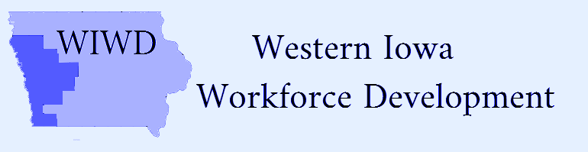
Voting Members | Present | Not Present
Clay Adams |  | x
Bill Anderson | x
Duane Bates |  | x
Ernest Colt | x
Sara DeAnda | x
Steve Early | x
Rebecca Finch | x
Brittney Gutzmann | x
Bridget Hoefling | x
Becky Jacobsen | x
Arnold Kesselring | x
Shelly Ackley Longfellow |  | x
Randall McQueeney | x
Jim Meyers | x
Brenda Perrin | x
Scott Punteney | x
Lori Stitz | x
Scott Utech | x
Pamela Woolridge | x

Attendees
Shawn Fick
Darin Haake
Kassi Howell
Tammy Herbert
Rick Hunsaker
Jean Logan
Andi Mann
Jes Marino
Faith Miller
Wane Miller
Rich Ruggles
Mark Thomsen
Elizabeth Waigard

Date: Wednesday, January 20, 2021/Time: 11:00am
Location: -zoom only
Local Board Meeting Minutes
Action Item
Call to Order-Bridget Hoefling
Action item
Roll Call and establish Quorum-Quorum established
Action item
Approval of Agenda-motion made by Bill Anderson and 2nd by Ernie Colt
Action item
Approve Agenda/Minutes of Previous Meeting-motion made by Scott Utech and 2nd by Becky Jacobsen
Action item
- Rick Hunsaker, Region XII COG/Mark Thomsen, Region XII COG-Fiscal Agent WIOA Western Iowa budget update
- Rick Hunsaker, Region XII COG-WIOA Plan Limits for Assistance
Service Provider Report: Scott Utech made motion for a $6000 cap for tuition assistance. Group discussion was held. Scott Utech rescinded the original motion. Scott Utech made the motion to amend the action to make the agreement retroactive to July 1, 2020 and will allow the Service Provider authority to exceed the $6000 limit with the understanding any instances of exceeding the limit will be reported to the LWIWD Board. Motion seconded by Scott Punteney. Motion carried.
- Shawn Fick; Direct of Missions, Goodwill of the Great Plains-reviewed written report
Action item
New Business:
- Board Support MOU Extension; Bridget Hoefling (Board Action)-motion made by Sara Deanda to extend current MOU (expiring January, 2021) with the Community Action Agency to June 30, 2021 and 2nd by Becky Jacobsen. Motion carried.
- Randall McQueeney; Operations Manager, Iowa Works (update-verbal report)-discussed topics of virtual job fairs, Cares Act Grants, Apprenticeship programs, re-employment and unemployment services.
- Brittney Gutzmann; Rehabilitation Supervisor, Iowa Vocational Rehabilitation Services (update-verbal report)-reviewed status of Iowa Vocational Rehabilitation Services in addition to, Disability Access Committee and the current remodeling efforts in Iowa Works locations to meet ADA compliance measures.
- Website update-planning efforts tentatively scheduled to begin February, 2021.

Action item
Next Meeting-Wednesday, May 19, 2021 physical location to be announced/zoom option
Action item
Public Comments-n/a
Action item
Motion to Adjourn made by Steve Early and 2nd by Scott Utech -motion carried

