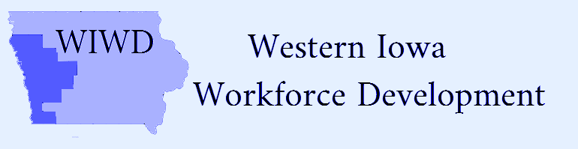
Voting Members | Present | Not Present
Clay Adams | x
Bill Anderson | x
Duane Bates | x
Ernest Colt | x
Sara DeAnda | x
Steve Early | x
Rebecca Finch | x
Brittney Gutzmann | x
Bridget Hoefling | x
Becky Jacobsen | x
Arnold Kesselring | x
Shelly Ackley Longfellow | x
Randall McQueeney | x
Jim Meyers | x
Scott Punteney | x
Lori Stitz | x
Scott Utech | x
Pamela Woolridge | x

Attendees
Scott Belt
Shawn Fick
Darin Haake
Tammy Herbert
Rick Hunsaker
Jean Logan
Wane Miller
Kaylene Page
Kassi Peregoy
Rich Ruggles
Linda Rouse
Mark Thomsen

Date: Thursday, October 22, 2020/Time: 10:00am
Location: -C.G. Therkildsen Activity Center, 706 Victoria St., Harlan, Iowa
Local Board Meeting Minutes
Action Item
Call to Order-Bridget Hoefling/Wane Miller
Action item
Introductions
Action item
Roll Call and establish Quorum-Quorum established
Action item
Approval of Agenda-motion made by Bill Anderson and 2nd by Steve Early
Action item
Approve Agenda/Minutes of Previous Meeting-n/a
Action item
- CLEO and CEO Executive Committee
- Bridget Hoefling, Interim chairman of the Local Board
- Support to Board, Jean Logan Executive Director of Community Action Agency of Siouxland
- Mark Thomsen, Region XII COG
Service Providers-
- Kaylene Page; Director of Workforce Development IWCC
- Shawn Fick; Direct of Missions, Goodwill of the Great Plains
Action item
New Business:
- Adopt LWIWDB By-Laws (Board Action)-motion made by Ernest Colt and 2nd by Scott Utech-motion carried
- Adopt LWIWDB Procurement Procedure Policy (Board Action)-motion made by Becky Jacobsen and 2nd by Bill Anderson-motion carried
- Elect Vice Chair and Secretary-Nomination for Secretary; Becky Jacobsen (accepted)-motion made by Bill Anderson and 2nd by Duane Bates (accepted)/Nomination for Vice Chair; Duane Bates-motion made by Becky Jacobsen and 2nd by Steve Early-motion carried
- Establish Executive Committee-nominations for Clay Adams, Duane Bates and Shelly Ackley Longfellow (accepted)-motion made by Becky Jacobsen and 2nd by Bill Anderson-motion carried
- RFP for Service Provider (Board Action)-motion made by Scott Utech and 2nd by Ernest Colt
- Apply for Transitional Grant (Board Action)-submission to Michelle McNertney for approval. Motion made by Bill Anderson and 2nd by Steve Early-motion carried
- Other grants-Shawn Fick and Kaylene Page
- Board Insurance-Jean Logan presented information
- Transportation/travel rates & procedures
- Meeting schedule-Executive Committee meeting November 24, 2020 10:00am regarding RFP submissions
- Board Training-October 29, 2020 10am-2pm
- State updates, Linda Rouse; District Manager, American Job Center Division, Iowa Workforce Development

Action item
Next Meeting-Monday, November 30, 2020 at 11:00
Action item
Public Comments-
Action item
Motion to Adjourn made by Bill Anderson and 2nd Ernie Colt-motion carried

