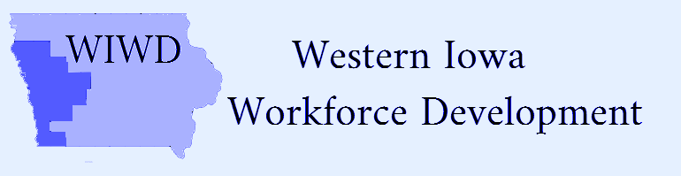
Voting Members | Present | Not Present
Clay Adams |  | x
Bill Anderson | x
Duane Bates | x
Ernest Colt | x
Sara DeAnda |  | x
Steve Early |  | x
Rebecca Finch | x
Brittney Gutzmann |  | x
Bridget Hoefling | x
Becky Jacobsen | x
Arnold Kesselring | x
Shelly Ackley Longfellow | x
Randall McQueeney | x
Jim Meyers |  | x
Brenda Perrin | x
Scott Punteney | x
Lori Stitz | x
Scott Utech | x
Pamela Woolridge | x

Attendees
Scott Belt
Shawn Fick
Darin Haake
Tammy Herbert
Rick Hunsaker
Jean Logan
Wane Miller
Kaylene Page
Rich Ruggles
Mark Thomsen

Date: Monday, November 30, 2020/Time: 11:00am
Location: -zoom only
Local Board Meeting Minutes
Action Item
Call to Order-Bridget Hoefling/
Action item
Introductions-new Board member Brenda Perrin
Action item
Roll Call and establish Quorum-Quorum established
Action item
Approval of Agenda-motion made by Bill Anderson and 2nd by Steve Early
Action item
Approve Agenda/Minutes of Previous Meeting-motion made by Ernie Colt and 2nd by Becky Finch
Action item
- Update on the Transitional Grant-Support to Board, Jean Logan Executive Director of Community Action Agency of Siouxland
Service Providers-
- Mark Thomsen, Region XII COG-Fiscal Agent WIOA Western Iowa budget update
- Kaylene Page; Director of Workforce Development IWCC
- Shawn Fick; Direct of Missions, Goodwill of the Great Plains
Action item
New Business:
- Adopt amended LWIWDB By-Laws (Board Action)-motion made by Scott Utech and 2nd by Becky Jacobsen-motion carried
- Request for Proposal for Adult and Dislocated Service Provider (Board Action)-motion made by Scott Utech and 2nd by Ernie Colt-motion carried
- Request for Proposal for Youth Service Provider-motion made by Ernie Colt and 2nd by Shelley Ackley Longfellow-motion carried
- COVID 19 National Dislocated Worker Grant-application completed-Jean Logan Executive Director of Community Action Agency of Siouxland will provide update.

Action item
Next Meeting-Wednesday, January 20, 2021 at 11:00 (zoom only)
Action item
Public Comments-Faith Miller of Carroll, Iowa IWD will be opening Denison, Iowa location January 4, 2021
Action item
Motion to Adjourn made by Scott Utech and 2nd by Pamela Woolridge-motion carried

